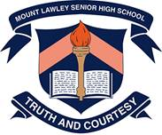
Year 7 Earth and Space Sciences 2022
Resources Test
Section 1: Multiple Choice Answers 1 mark each
Read all answers and choose the BEST one.
- Recall the largest source of evaporation in the water cycle.
A The oceans, because they are the largest bodies of water
B Vegetation, because the leaves of trees and other plants have such a large surface area
C Turbulent rivers and streams and waterfalls where there is a lot of spray going into the air
D Spray irrigation of large agricultural areas

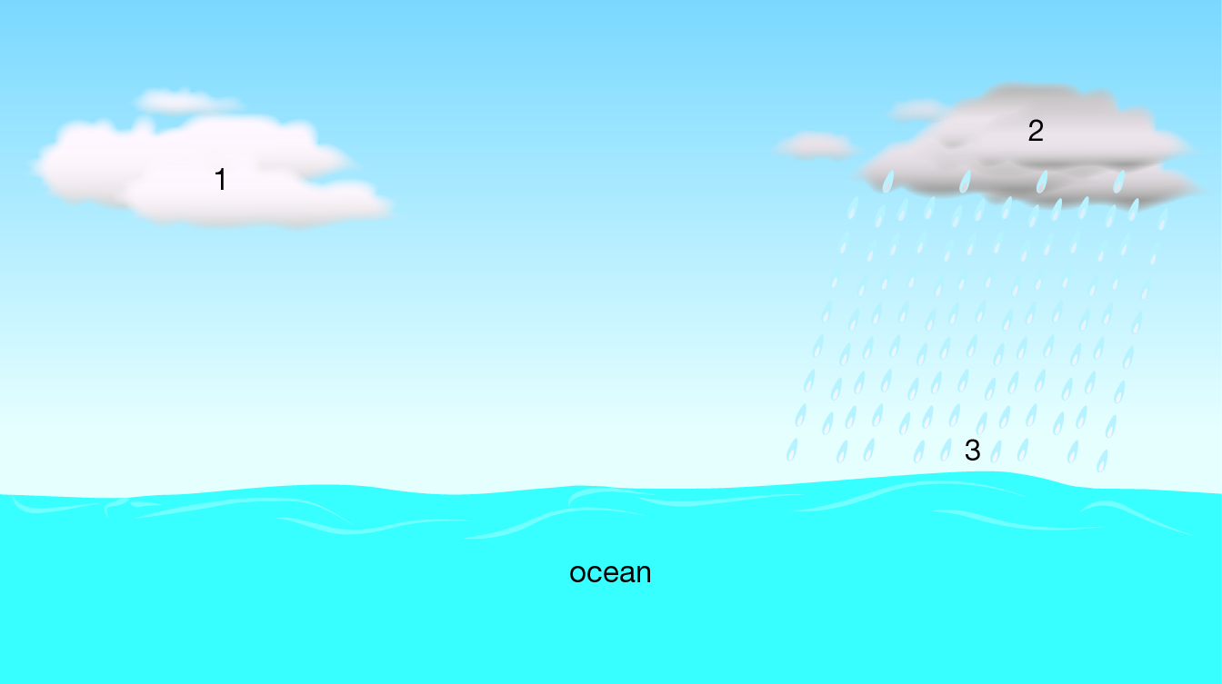
- Using the information provided in the diagram, deduce (figure out) which of the following statements is untrue.

4

A The air at 1 is saturated (full of water vapour).
B Evaporation is taking place at 4.
C Run-off will occur when the precipitation reaches 3.
D The water droplets in 1 are smaller than at 2.

- Runoff occurs when:
A the atmosphere is saturated with water.
B the ground is saturated with water.
C it goes too long without raining.
D a soil is too porous.

- Air is saturated (full of water vapour) when humidity reaches 100%. Which of the following conditions will allow least evaporation to occur from a leaf?
A Temperature of 15°C with humidity at 80%
B Temperature of 17°C with humidity at 75%
C Temperature of 20°C with humidity at 60%
D Temperature of 25°C with humidity at 50%

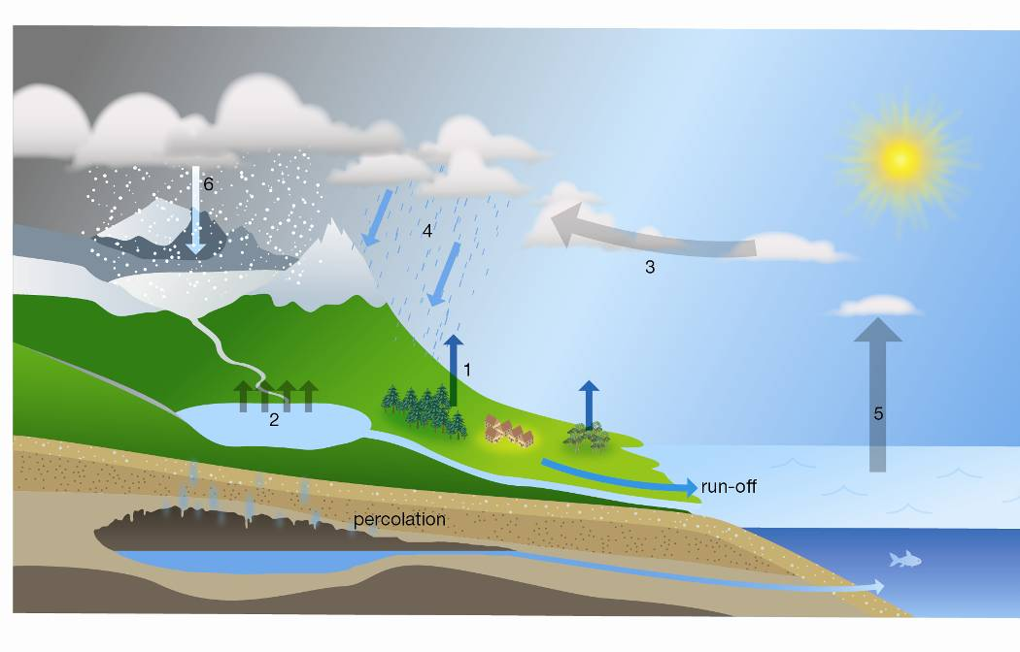
- The diagram below shows the Water Cycle. Deduce (figure out) the process occurring at position 1.

A precipitation
B evaporation
C condensation
D transpiration

- Use the diagram above to deduce the process occurring at position 2.
A precipitation
B evaporation
C condensation
D transpiration

- Use the diagram above to deduce the process occurring at position 4.
A precipitation
B evaporation
C condensation
D transpiration

- Which answer below shows the correct distribution of water on earth?
A 95% Salt water; 2.5% Trapped Fresh Water; 2.5% Renewable Fresh Water
B 97% Salt water; 2.49% Trapped Fresh Water; 0.01% Renewable Fresh Water
C 95% Salt water; 2.49% Trapped Fresh Water; 0.01% Renewable Fresh Water
D 97.5% Salt water; 2.49% Trapped Fresh Water; 0.01% Renewable Fresh Water

- The hydrologic cycle is primarily driven by;
A action of plant roots.
B infiltration of water into the soil.
C runoff of water into the Earths’ oceans.
D solar energy

- Where does some of the water from the water cycle collect underground?
A Aquariums.
B Aquifers.
C Aqueducts.
D Aquatic parks.

- The water that was on Earth when the dinosaurs roamed the Earth;
A Is gone, and has been for a long time.
B Is about halfway gone.
C Is the same water we use today.
D Would be really dirty if it were still around today.

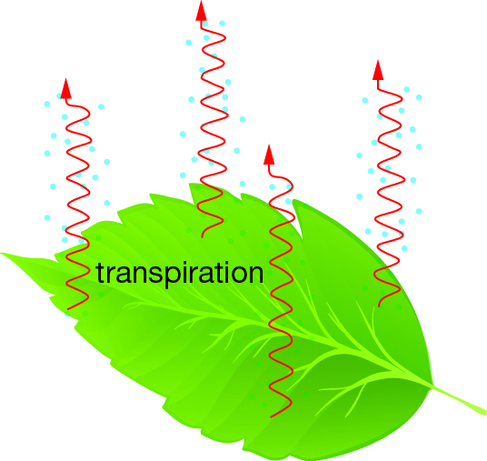
- Transpiration is water loss from plants, especially from the leaves. Which of the following events is least likely to occur.

A The rate of transpiration will slow down as the air above the leaf becomes saturated.
B The rate of transpiration will increase if a breeze begins to blow over the leaf.
C Transpiration will continue at a constant rate as long as there is water in the leaf, whatever the conditions around the leaf.
D The rate of transpiration will increase as the temperature rises in the middle of the day.

- Pervious rock allows water to percolate into it. Impervious rock does not allow water to percolate into it. Using the information in the diagram below, deduce which of the following events is least likely to occur.
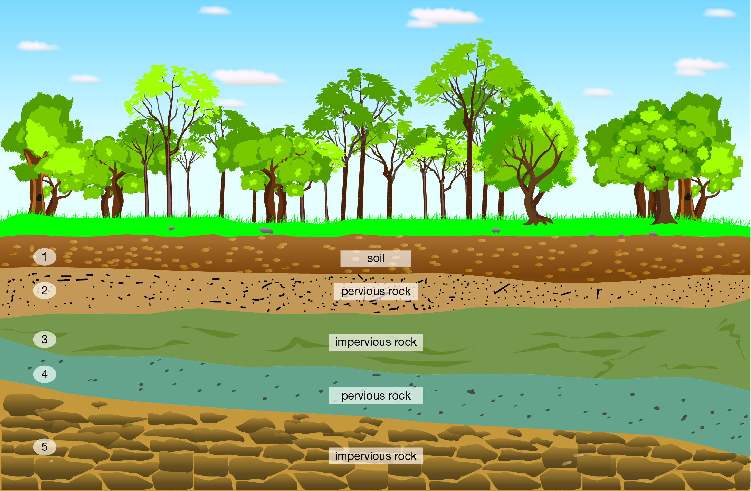

A There may be underground water in layers 2 and 4.
B A pool of Groundwater may develop in layer 4.
C Layers 3 and 5 will have water percolating through them.
D Water may enter layer 4 somewhere else a long way from this site.
- As times goes by, and water goes through the water cycle again and again, the amount of
water on Earth;
A Increases.
B Decreases.
C Stays the same.
D Goes up and down.

- Goran and Diana did an experiment on soils to study how water passed through them. They set up the equipment shown below.
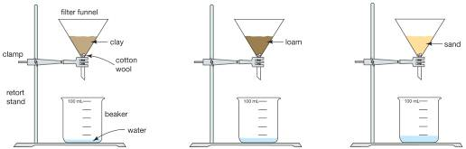
They poured 100 mL of water into each sample of soil and after 10 minutes they recorded their results in this table:
Soil type | Water in beaker (mL)
clay | 5
loam | 15
sand | 33

Which of the following is a correct deduction (conclusion) made by the students?
A Sand holds onto water better than clay and loam.
B More water drains through clay than through sand and loam.
C Loam is more permeable (means: let’s water through) than sand.
D Clay is less permeable (means: let’s water through) than sand and loam.

- Rank the states of matter from slowest to fastest particle speed;
A gas, solid, liquid.
B solid, liquid, gas.
C gas, liquid, solid.
D Solid, gas, liquid.

- If enough thermal energy was REMOVED from B in the diagram below, it would change into;
A A
A B C
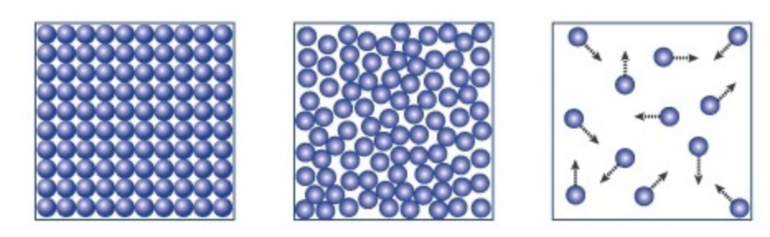
B water vapour.
C C
D liquid water.

- Select the list of renewable energy sources from the choices below.
A energy from coal, geothermal energy, tidal energy
B wind energy, tidal energy, hydroelectric energy
C solar energy, nuclear energy, wind energy
D energy from coal, nuclear energy, wind energy

- Rocks are weathered to form sediments that then make up soil. Soils would therefore contain which of the following material that was originally part of the rock.
A air
B water
C minerals
D fibres

- Soils are not renewable because they:
A can be eroded.
B are replaced too slowly.
C are formed from weathering of rocks.
D can be weathered.

- Some students were asked to classify some of Earth’s resources into renewable resources and non-renewable resources. Their answer is shown in the following table:
Renewable resources | Non-renewable resources
1 water | 7 rocks
2 natural gas | 8 air
3 sunlight | 9 coal
4 soil | 10 petroleum
5 waves | 11 wind
6 hydro-electric | 12 nuclear
Which resources (using the number) did the students classify incorrectly?
A 1, 4, 7, 8
B 2, 7, 8, 12
C 2, 4, 8, 11
D 1, 4, 8, 11

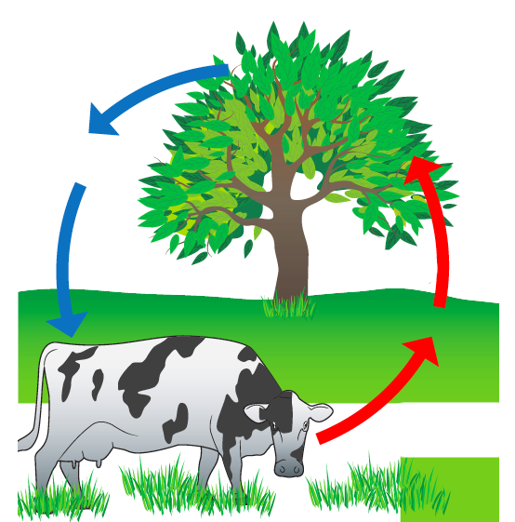
- In the picture below the arrows for box 1 indicate the movement of what:
A Breathing
B Oxygen
C Photosynthesis
D Carbon Dioxide
1.

2.

- In the picture above the arrows for box 2 indicate the movement of what:
A Breathing
B Oxygen
C Photosynthesis
D Carbon Dioxide

- A lunar eclipse is when:
A the Moon travels around Earth in an orbit shaped like an oval.
B Earth blocks sunlight from reaching the Moon.
C the Moon blocks sunlight from reaching the Sun.
D you only see part of the Moon because of its angle to the Sun.

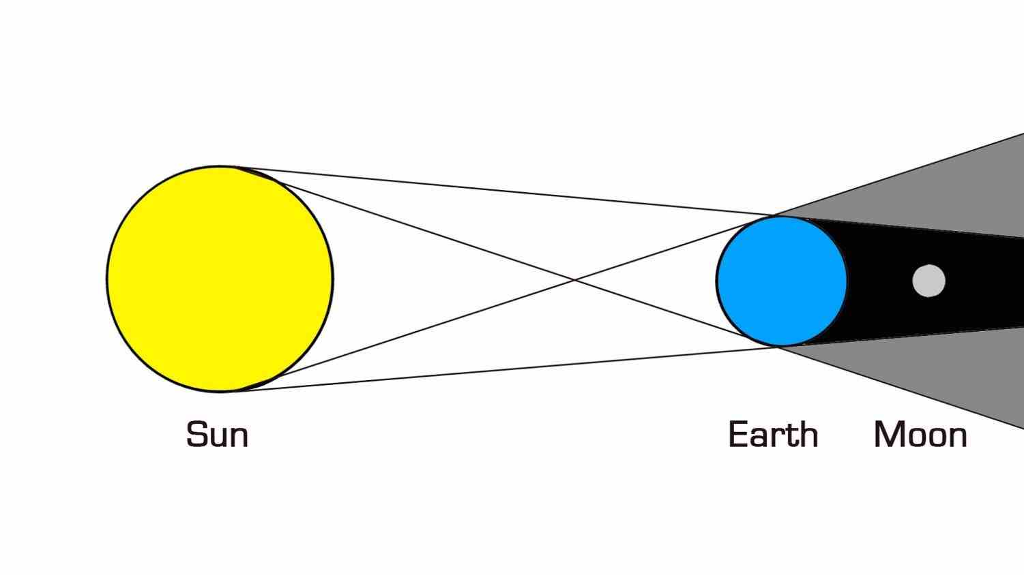
- What is occurring the picture below:
A A Partial Solar Eclipse
B A Partial Lunar Eclipse
C A Total Lunar Eclipse
D A Total Solar Eclipse

- End of Multi Choice Section -

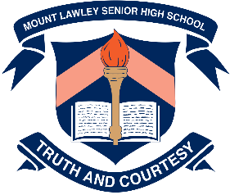 | Mount Lawley Senior High School
Year 7 2022 – Earth and Space Science – Ed-Unit Test
Water Cycle and Resources
Name: ___________________________________________________________
Class: _____________________________ Date:_____________________

Section A: Multiple Choice – Please SHADE the best suited answer 25 marks

- A B C D
- A B C D
- A B C D
- A B C D
- A B C D

- A B C D
- A B C D
- A B C D
- A B C D
- A B C D

- A B C D
- A B C D
- A B C D
- A B C D
- A B C D

- A B C D
- A B C D
- A B C D
- A B C D
- A B C D

- A B C D
- A B C D
- A B C D
- A B C D
- A B C D
Multiple Choice: ________ /25
Short Answer: ________ / 38

TOTAL: / 63

Section 2: Short Answer - Total 38 marks
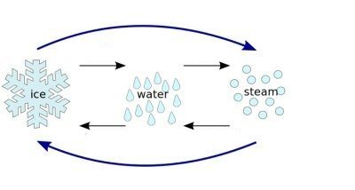
1. Label the 6 arrows on the diagram below (6 marks)
Sublimation
Not Frezzing

Melting
Evaporating

Freezing
Condensation

Deposition

2. Complete the following sentence: (2 marks)
faster
The greater the amount of energy placed on the water, the _____________________ the water molecules move and the _______________________ spread out they become.
more/further

3. Choose any 2 Factors and Circle how it effects the Water Cycle and Explain why it effects.
FACTORS NOT PROCESSES – must answer the question (4 marks)

Factor 1- ___________________: Effect: Speeds up OR Slows down (circle one)
1/2 mark for correct factor ½ mark Speeds up or slows down the cycle
1 mark for explaining why it has that effect – scientific reasoning
Explanation: ___________________________________________________________________
______________________________________________________________________________
______________________________________________________________________________

Factor 2 - ___________________: Effect: Speeds up OR Slows down (circle one)
1/2 mark for correct factor ½ mark Speeds up or slows down the cycle
1 mark for explaining why it has that effect – scientific reasoning
Explanation: ___________________________________________________________________
______________________________________________________________________________
______________________________________________________________________________

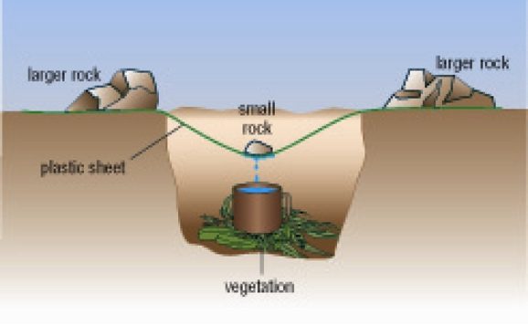
4. When vegetation (plants) decomposes (breaks-down),
the moisture (water) in their cells is released to the environment.

Propose how the equipment shown is this diagram could be
used to provide a source of water if you were lost in the bush
and had access to vegetation.

(3 marks)
Water evaporates from the vegetation. – 1 mark
Water vapour rises and condenses on the plastic sheet. – 1 mark
The water runs down the inside of the plastic sheet and collects under the small rock. – 1 mark
When there is enough water, it starts to drip down into the cup.

______________________________________________________________________________
______________________________________________________________________________
____________________________________________________________________________________________________________________________________________________________
5 a. State 2 example of a renewable energy source (2 marks)
1 mark each. Any 2 of: Solar, Wind, Geothermal, Waves, Tidal and Hydroelectric

_______________________________________________________________________________________
b. State 2 examples of a non-renewable energy source (2 marks)
1 mark each. Any 2 of: Coal, Oil, Gas, Fossil fuels, Nuclear (if Fossil fuel is one answer then cannot have coal/oil/gas as the second answer)

_______________________________________________________________________________________

c. Recall one advantage of using one of the non-renewable energy sources you stated above.
(1 mark)
Fossil Fuels (coal/oil/gas) = Ready to use, Cheap (Easy to make = ½)
Nuclear = Clean – no pollution, small amount produces a lot of energy, materials are cheap

_______________________________________________________________________________________
_______________________________________________________________________________________
d. Recall one disadvantage associated with one of the non-renewable energy sources you stated above. (1 mark)
Fossil Fuels (coal/oil/gas) = Release greenhouse gasses (bad for environment = ½)
Nuclear = expensive to run, toxic waste, leakage causes devastating damage. (no leakage = 1/2 )
RUNNING OUT = 0 marks
______________________________________________________________________________________________________________________________________________________________________________
6. Match terms to definitions by putting the number in the box next to the term. (6 marks)
2
6
4
5
1
3
Photosynthesis 1. Anything obtained from earth that satisfies the needs of living things.
Minerals 2. The process in which Carbon Dioxide is taken and Oxygen is given.
Solar Energy 3. Energy source that uses the heat from the ground to turn water into steam.
Coal 4. Energy from Sunlight is captured and converted into Electricity.
Resources 5. Non-renewable source of energy.
Geothermal 6. Non-renewable resource that we mine from rocks.
7a. Explain why rocks and soils are non-renewable resources, but living things are renewable.
(2 marks)

Rock and soil take a very long time (longer than human life) to be replaced [not reproduced] – 1 mark
Living things reproduce ( ½ marks for term) within a lifetime – ½ mark OR replaced by offspring – ½ mark

b. State 2 examples of how living things are used as resources (2 marks)
1 mark each. Any 2 of: Trees for oxygen/building/furniture/wood
Plants for food/clothing/medicine Animals for food/clothing.

_______________________________________________________________________________________
_______________________________________________________________________________________

8. a) Construct a labelled diagram to show what a Solar eclipse is. (4 marks)
(Remember to name the parts of the shadow).
O = Order T = Terminology
1 mark – correct position of Sun, Moon, Earth
1 mark – earth and sun are labelled
1 mark – moon is labelled (1/2) and it’s shadow does not cover all of earth (1/2)
Shadows don’t spread out
1 mark – Umbra and Penumbra are labelled

.

b) Explain why we can have a Full Moon sometimes and a Lunar eclipse at other times.
(3 marks)
Because the moon orbit is tilted – 1 mark Moon is not tilted!
The moon will sometimes go into earth’s shadow = Lunar Eclipse – 1 mark
Most of the time, the moon will not go into earth’s shadow = full moon – 1 mark

- End of Test –

